Rolling correlation: AUDUSD and USDJPY
Method 05 / daily log returns / windows 20, 60, 100 / Low-value

Study setup
Logical pair: AUDUSD , USDJPY
Broker symbols: AUDUSD_i , USDJPY_i
Tier: Low-value (low_value)
Snapshot: 2026-11-03_majors_alpari_D1
Timeframe: D1
Matched return window: 1999-01-05 to 2026-11-02 (UTC bar dates)
Matched return count (rows before rolling): 7199
Dropped unfinished last bar dated 2026-11-03 UTC after a tick-volume check against the prior complete day.
Rolling windows W: 20, 60, 100 trading days
Live-shaped n for each score: n = W (not the full history length)
Complete matched rows (CSV): AUDUSD-USDJPY_Rolling_D1.csv
Complete matched rows (HTML): AUDUSD-USDJPY_Rolling_D1_data.html

Method carried forward
Rolling Pearson r is computed on matched daily log returns of close, ln(close_t / close_t-1), in the broker quote direction. Quotes are not inverted. For each day t with a full window, r_W uses the last W matched return pairs ending at t. That live-shaped sample size is W (20, 60, or 100), not the full multi-year history. The first W-1 days have no score. r is symmetric under swap of the two symbols. A high |r| in one window does not prove cause, lead-lag, or a trading signal. Short windows are noisier; long windows are slower to reflect a break.
How to read a live day: after both daily candles close, the newest r_20 uses the last 20 matched log returns, r_60 the last 60, and r_100 the last 100. Compare those three to each other and to the full-sample baseline below. A break is when the short window moves far from the baseline or flips sign while the baseline was meaningful.

Full-sample Pearson baseline (method 01 v001)
Copied full-sample Pearson r for AUDUSD-USDJPY: -0.088151. This is a historical average link, not the live state.

Rolling results
W | latest_r | mean | median | min | max | std | pct_|r|>=0.4 | pct_|r|>=0.7 | n_roll
20 | 0.030926 | -0.243031 | -0.300899 | -0.927825 | 0.91749 | 0.380564 | 47.3 | 10.45 | 7180
60 | -0.465814 | -0.226325 | -0.26926 | -0.796553 | 0.767092 | 0.317389 | 37.97 | 2.72 | 7140
100 | -0.440955 | -0.21628 | -0.246268 | -0.7687 | 0.69504 | 0.299004 | 35.85 | 0.94 | 7100
n_roll is the number of days that had a complete window. pct_|r|>=0.4 and pct_|r|>=0.7 are the share of those days where the absolute rolling correlation cleared the threshold.

Conclusion
For AUDUSD and USDJPY, full-sample Pearson baseline r=-0.0882. Latest rolling scores: r_20=0.0309, r_60=-0.4658, r_100=-0.4410. Stability: moderate window-to-window variation. Agreement with baseline: r_20=0.031 opposite sign vs baseline; r_60=-0.466 far from baseline (0.38); r_100=-0.441 far from baseline (0.35). Tier line: low interest historically; check only if a short window spikes. This is a monitoring summary, not a trade signal.

What to look at in this file next time
1) Latest r_20 vs r_60 vs r_100 in the results table. 2) Whether short-window latest has the same sign as the baseline. 3) The rolling chart for stretches where |r| collapsed. 4) The CSV if you need a different chart later.

Charts
Rolling Pearson r (20 / 60 / 100)
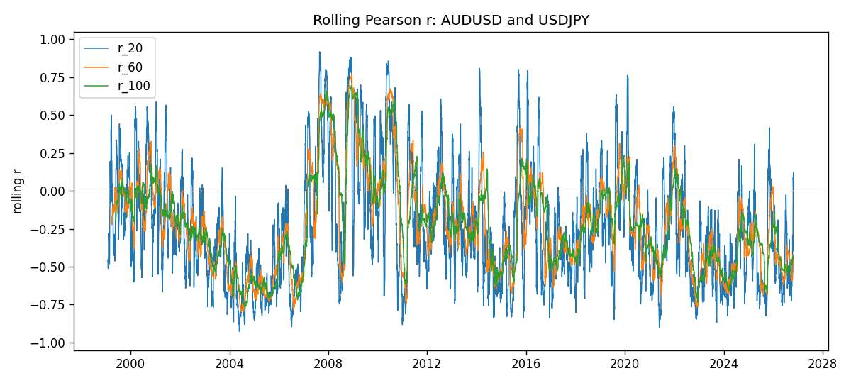
Daily closes

Daily log returns
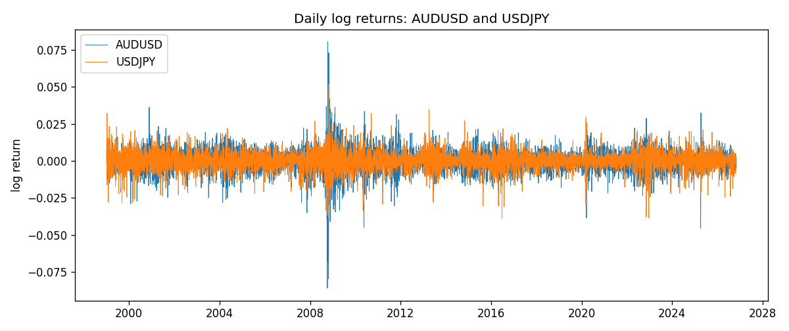

Data report
Every matched row with r_20, r_60, and r_100 is in the sibling CSV and HTML. This Word section holds column summaries and the first and last 15 rows of the rolling table.
Columns: time, AUDUSD_close, USDJPY_close, AUDUSD_tick_volume, USDJPY_tick_volume, AUDUSD_log_return, USDJPY_log_return, r_20, r_60, r_100
Column summaries
column | count | mean | std | min | 25% | 50% | 75% | max
AUDUSD_close | 7199 | 0.752023 | 0.135259 | 0.4786 | 0.661195 | 0.73175 | 0.809235 | 1.10169
USDJPY_close | 7199 | 113.824 | 19.2223 | 75.811 | 104.42 | 111.025 | 120.687 | 163.851
AUDUSD_tick_volume | 7199 | 77366.8 | 138150 | 109 | 5440 | 43349 | 71344.5 | 1.23462e+06
USDJPY_tick_volume | 7199 | 106152 | 179316 | 197 | 9927 | 53098 | 92761 | 1.80351e+06
AUDUSD_log_return | 7199 | 2.78e-05 | 0.00754502 | -0.0860252 | -0.00385397 | 0.00028846 | 0.00415332 | 0.0806166
USDJPY_log_return | 7199 | 4.761e-05 | 0.00620532 | -0.039082 | -0.00320306 | 0.00011368 | 0.00340781 | 0.0518402
r_20 | 7180 | -0.243031 | 0.380564 | -0.927825 | -0.537466 | -0.300899 | -0.0247559 | 0.91749
r_60 | 7140 | -0.226325 | 0.317389 | -0.796553 | -0.474834 | -0.26926 | -0.0208013 | 0.767092
r_100 | 7100 | -0.21628 | 0.299004 | -0.7687 | -0.441773 | -0.246268 | -0.0275602 | 0.69504
First 15 matched rows
time | AUDUSD_close | USDJPY_close | AUDUSD_log_return | USDJPY_log_return | r_20 | r_60 | r_100
1999-01-05 | 0.6215 | 111.92 | -0.000804182 | -0.000178683
1999-01-06 | 0.6289 | 112.77 | 0.0118364 | 0.00756602
1999-01-07 | 0.6345 | 111.33 | 0.00886503 | -0.0128516
1999-01-08 | 0.6347 | 110.8 | 0.000315159 | -0.00477199
1999-01-11 | 0.6393 | 109.02 | 0.00722138 | -0.0161954
1999-01-12 | 0.6362 | 112.6 | -0.00486085 | 0.0323104
1999-01-13 | 0.6312 | 113.52 | -0.00789021 | 0.00813732
1999-01-14 | 0.6295 | 113.52 | -0.00269692 | 0
1999-01-15 | 0.634 | 114.15 | 0.0071231 | 0.00553434
1999-01-18 | 0.6346 | 114.16 | 0.000945925 | 8.76002e-05
1999-01-19 | 0.6392 | 113.52 | 0.00722252 | -0.00562194
1999-01-20 | 0.64 | 112.91 | 0.00125078 | -0.00538799
1999-01-21 | 0.6405 | 113.87 | 0.000780945 | 0.00846641
1999-01-22 | 0.6327 | 114.56 | -0.0122527 | 0.00604126
1999-01-25 | 0.6302 | 113.72 | -0.00395915 | -0.00735942
Last 15 matched rows
time | AUDUSD_close | USDJPY_close | AUDUSD_log_return | USDJPY_log_return | r_20 | r_60 | r_100
2026-10-13 | 0.69821 | 158.305 | 0.00350077 | -0.00189328 | -0.489893 | -0.583673 | -0.469755
2026-10-14 | 0.69715 | 158.317 | -0.00151932 | 7.58002e-05 | -0.418538 | -0.583527 | -0.468845
2026-10-15 | 0.69191 | 158.024 | -0.00754471 | -0.00185243 | -0.292052 | -0.55339 | -0.454003
2026-10-16 | 0.69426 | 157.964 | 0.00339064 | -0.000379761 | -0.39756 | -0.551639 | -0.454364
2026-10-19 | 0.6978 | 158.517 | 0.005086 | 0.00349468 | -0.302222 | -0.527624 | -0.437963
2026-10-20 | 0.70022 | 158.16 | 0.00346204 | -0.00225466 | -0.330696 | -0.527676 | -0.443829
2026-10-21 | 0.70275 | 158.108 | 0.00360664 | -0.000328835 | -0.139788 | -0.531123 | -0.445102
2026-10-22 | 0.70186 | 156.755 | -0.00126726 | -0.00859427 | -0.0180967 | -0.421283 | -0.433743
2026-10-23 | 0.70353 | 156.81 | 0.00237657 | 0.000350804 | 0.089278 | -0.422198 | -0.443128
2026-10-26 | 0.70128 | 157.458 | -0.00320328 | 0.00412387 | 0.01849 | -0.45383 | -0.446987
2026-10-27 | 0.70245 | 157.894 | 0.00166699 | 0.00276517 | 0.0202397 | -0.483313 | -0.442654
2026-10-28 | 0.70533 | 157.743 | 0.00409155 | -0.000956795 | 0.027772 | -0.482585 | -0.441622
2026-10-29 | 0.70245 | 157.683 | -0.00409155 | -0.000380438 | 0.098213 | -0.468558 | -0.433823
2026-10-30 | 0.70316 | 157.516 | 0.00101024 | -0.00105965 | 0.120219 | -0.459642 | -0.434169
2026-11-02 | 0.69971 | 157.933 | -0.0049185 | 0.00264385 | 0.0309257 | -0.465814 | -0.440955

